**Report on Analysis using Perftrack.**

Perftrack gives us the option of selecting metrics helping u do the analysis of the three chillers keeping one particular metric like loads, ECWT etc in mind. Following graphs shows a detailed analysis of data. We have analyzed few values using Perftrack graphs . Due to the limitation of perftrack, not being able to give other suitable formats of graphs, we imported the data into csv format after the filtering and metric selection done via perftrack.

Screenshots accompanies on next page.

1. Chiller Loads

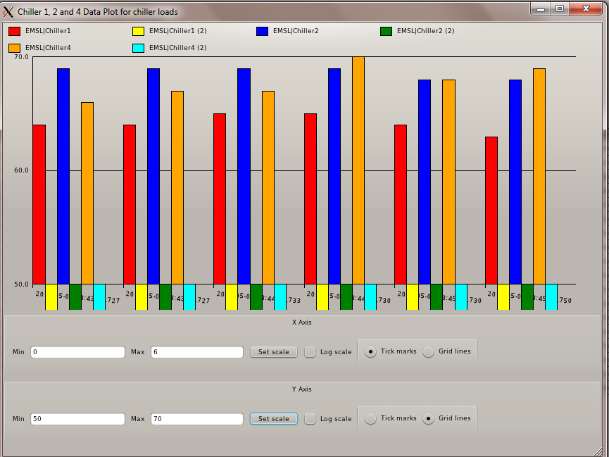

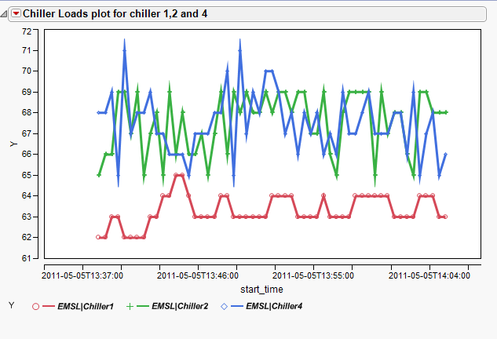

1. Chiller KW

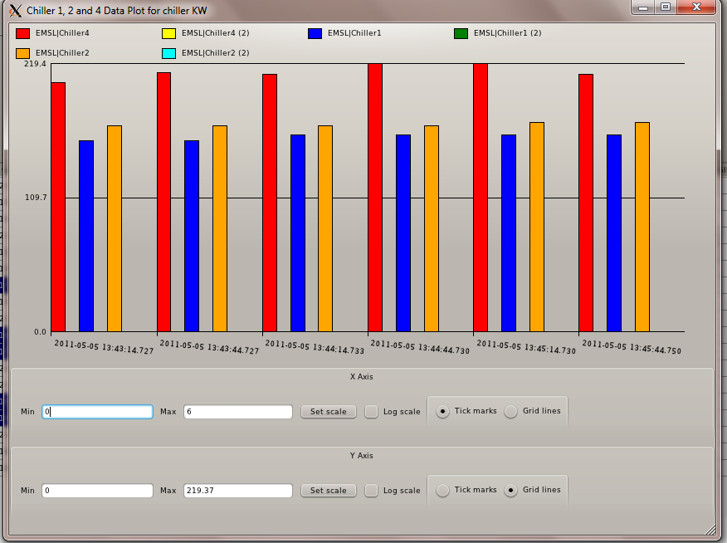

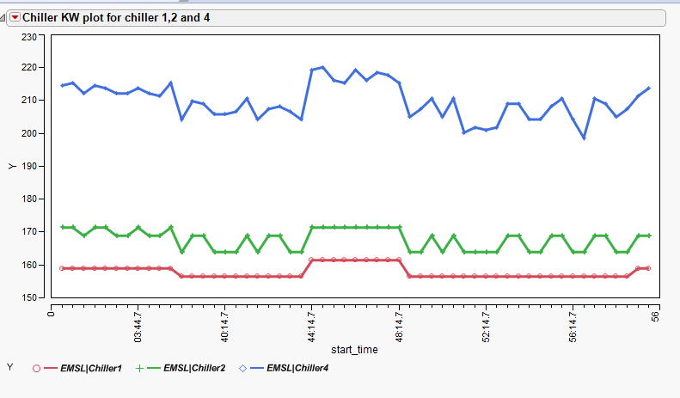

1. Chiller ECWT

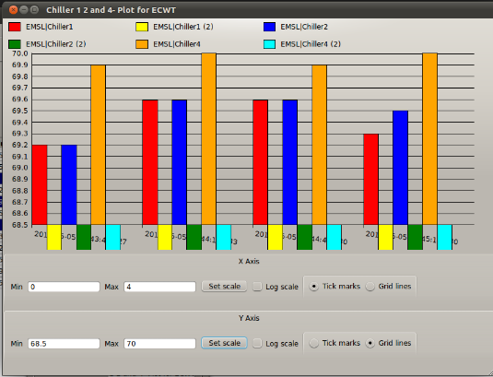

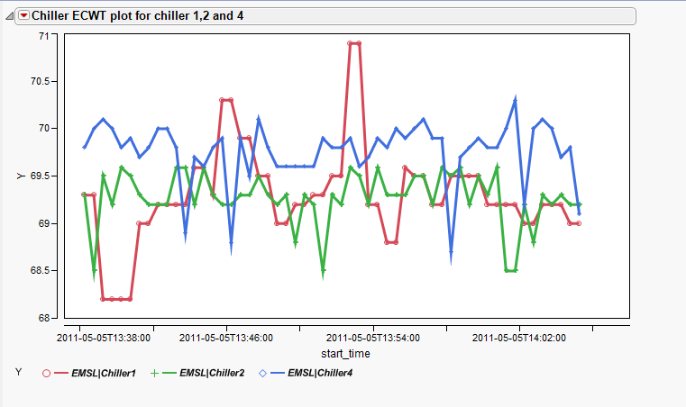

1. Chiller Evap Pressure

